# Performance Report

After completing 50 training epochs, the YOLOv8 model was evaluated using the validation dateset. The validation process generated several key metrics used to measure detection quality and localization accuracy.

|  |  |  |
| --- | --- | --- |
| Metric | Score | Meaning |
| Precision | 0.862 | Correct detection's are high; few false alarms |
| Recall | 0.818 | Model finds most number plates |
| mAP50 | 0.829 | Strong localization at standard IoU threshold |
| mAP50-95 | 0.505 | Good performance even under strict overlap requirements |

## 1. Precision – 0.862

Precision represents how many of the detected number plates were correct. A precision score of 0.862 (86.2%) means that most predicted bounding boxes contained an actual license plate, indicating very few false positives.

## 2. Recall – 0.818

Recall measures how many real number plates the model successfully found. A recall score of 0.818 (81.8%) means the model detected most of the plates in the images, with very few missed detection's.

## 3. mAP50 – 0.829

mAP50 stands for Mean Average Precision at IoU = 0.50. This means that if the predicted bounding box overlaps at least 50% with the real plate, it counts as a correct detection. A result of 0.829 (82.9%) indicates the model is highly accurate at identifying the location of plates.

## 4. mAP50-95 – 0.505

This score averages detection accuracy across 10 different IoU thresholds (from 50% overlap up to 95% overlap). This metric is stricter and more challenging. A value of 0.505 (50.5%) means the model can still correctly localize plates even when the accuracy requirement becomes tighter.

## Future Enhancements

• Increase data set size to improve generalization  
• Test YOLOv8m or YOLOv8l for higher accuracy with large data set  
• Integrate model into real-time applications such as toll systems or parking gates  
• Further train for higher mAP50-95 for stricter bounding box accuracy

Author:Karthik Muruganathem .

# Additional Evaluation Visualizations

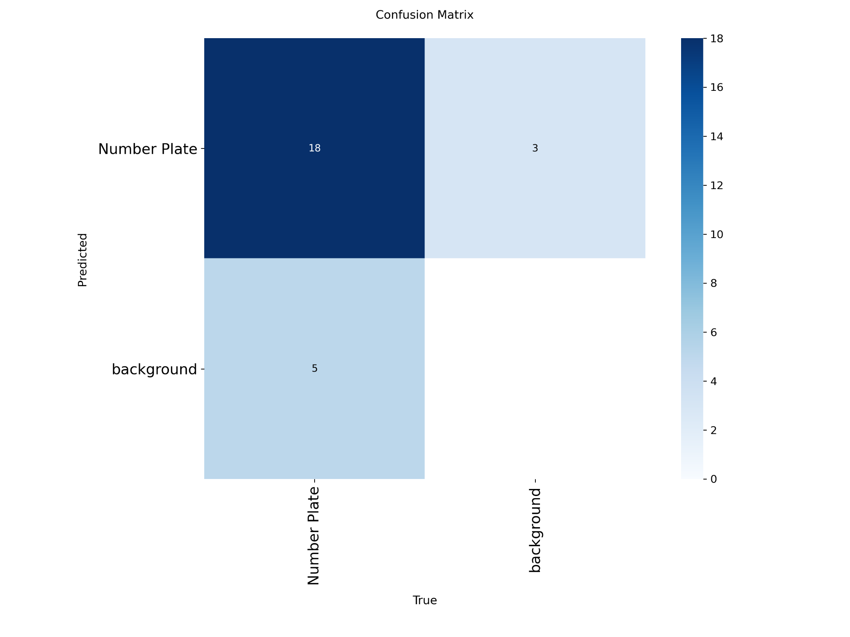

Confusion Matrix: Shows correct vs incorrect classifications for Number Plate and Background.

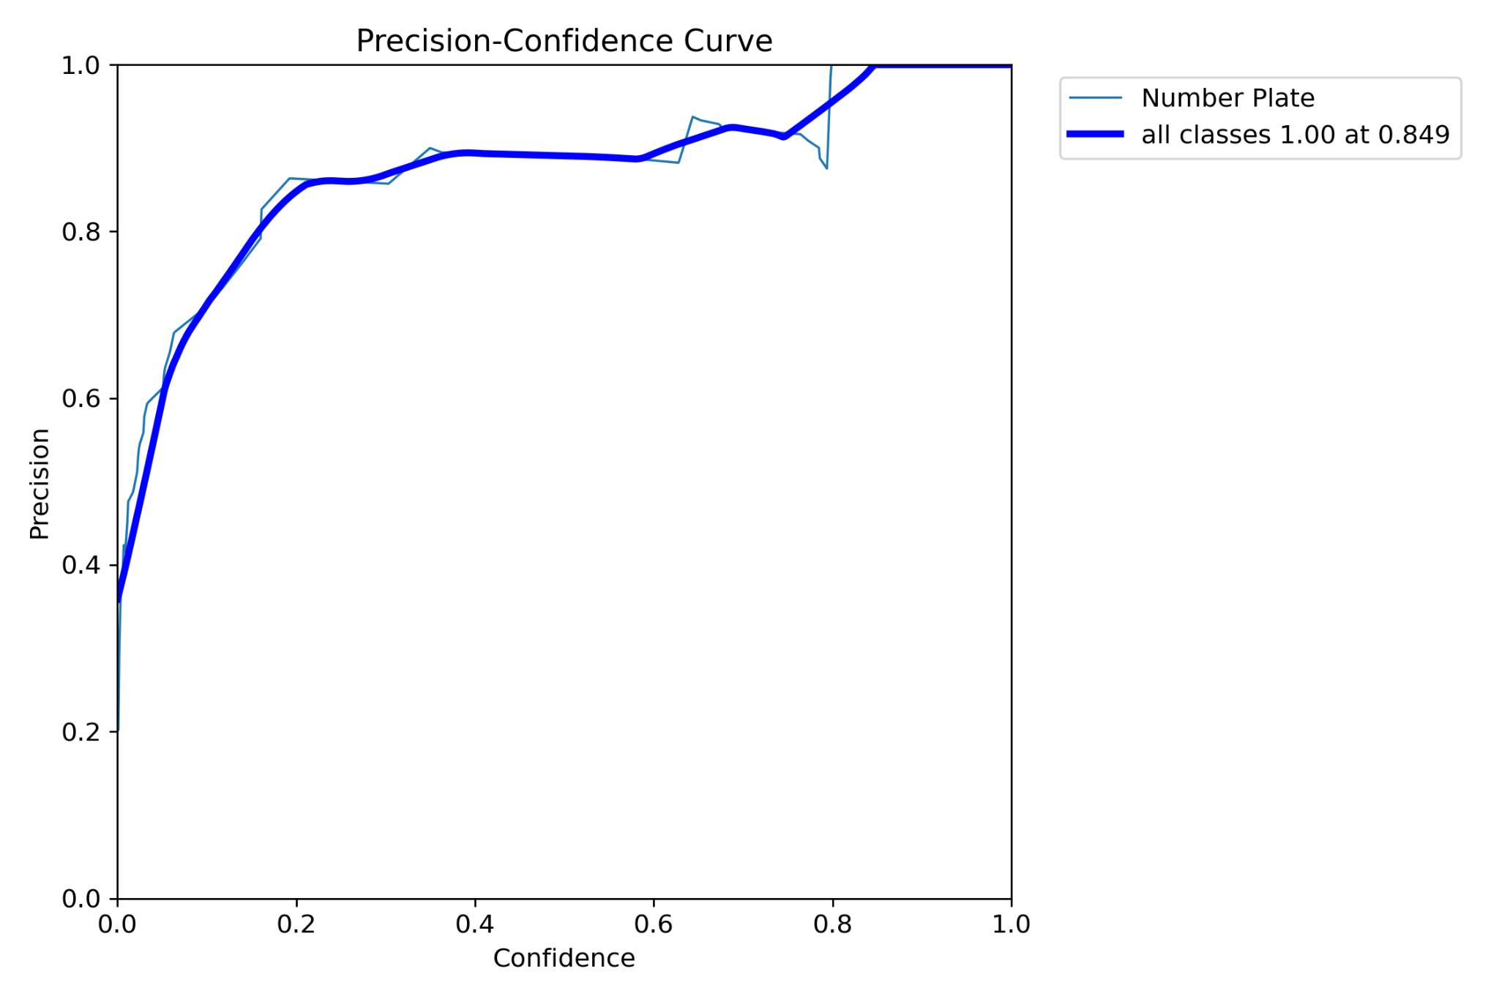

Precision-Confidence Curve: Demonstrates how precision changes with different confidence thresholds.

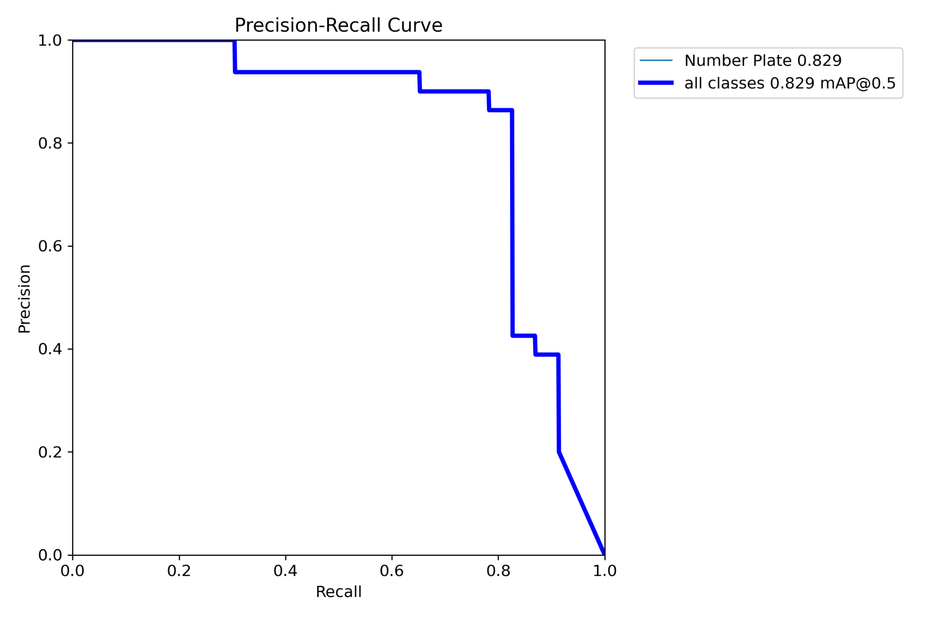

Precision-Recall Curve: Illustrates trade-off between precision and recall as model confidence varies.

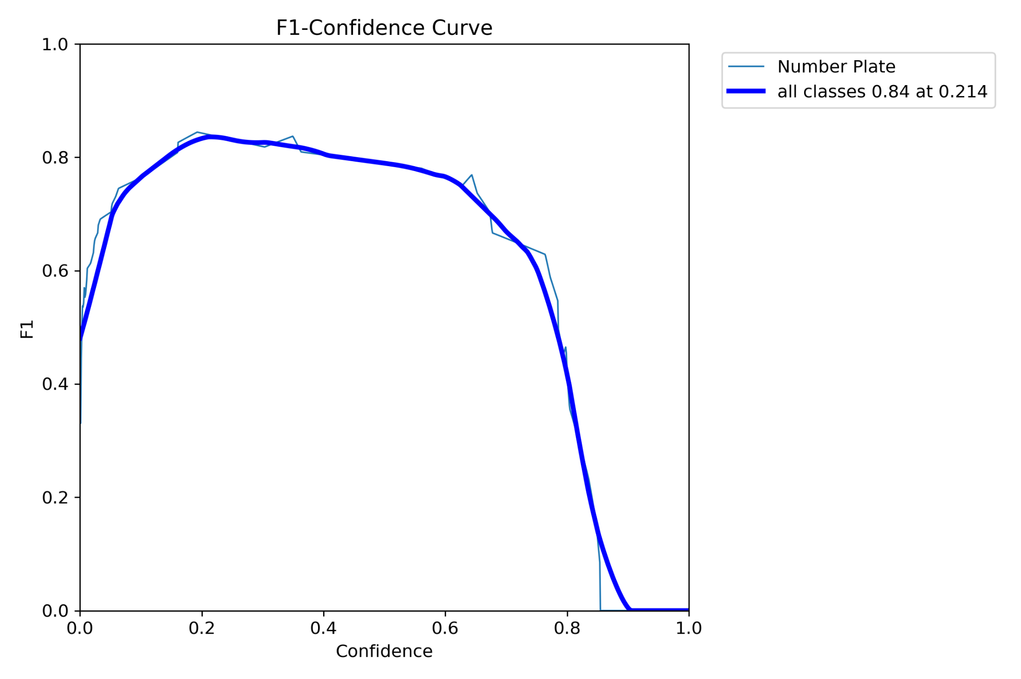

F1-Confidence Curve: Displays F1-score variation across confidence levels, balancing precision and recall.